Free and Reduced Lunch Eligibility in US Public Schools
Lucas Libelo, Parasmai Salunkhe
Thomas Jefferson High School for Science and Technology
Machine Learning
Dr. Yilmaz

Goal
Our goal is to aid in the allocation of financial and dietary resources to schools who need them the most. We will be using multiple accessible data points to predict the number of students that are eligible for free and reduced-price lunch.

Original Dataset Description
We chose a federal dataset of public school characteristics, each of the 101,390 instances representing a public school. The dataset contains 75 attributes, and has a dimension of 74. For the purposes of this project, the class attribute is TOTFRL, the number of students that are eligible for free or reduced-price lunch. Across all attributes, the total number of missing values is 1,078,417. In addition, there are many impossible values such as -1 in multiple attributes. The name, description, and number of missing values of each attribute can be found in the appendix.
The class data is heavily skewed right, with a mean of 245.605 and a standard deviation of 286.334. The majority of these values lie close to zero. The data also has some outliers; the instance with the highest number of students eligible for free or reduced-price lunch has 10,074 such students.
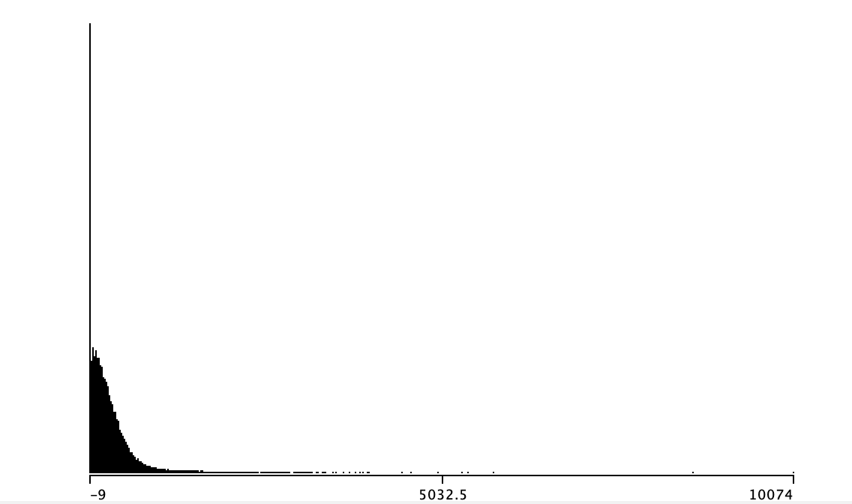
Distribution of class data

Preprocessing

Cleaning

Issue 1: Irrelevant Attributes
This dataset contains many attributes that clearly cannot be used to predict the class label. To speed up preprocessing of attributes, we began with removing these attributes. The columns that were removed in this step are: OBJECTID, NCESSCH, SURVYEAR, STABR, LEAID, ST_LEAID, LEA_NAME, SCH_NAME, LSTREET1, LSTREET2, PHONE, LATCOD, and LONCOD. Attributes and their descriptions can be found in the appendix.

Issue 2: Repetitive Attributes
The grade attributes (PK, KG, G01-G13, AE, and UG) each have greater than 45% of values missing. The dataset also contains the school level, such as elementary or high school, and the total number of students at each school. SCHOOL_LEVEL and TOTAL summarize the data provided by the individual grade attributes. To simplify the dataset and sidestep the large proportion of missing values of the grade attributes, we removed the grade attributes, as well as the GSLO and GSHI.
Because we are predicting the total number of students eligible for free or reduced-price lunch, the attributes FRELCH and REDLCH would include the exact same data. For this reason, we removed these two attributes.

Issue 3: Special Values
According to the NCES, the organization that provided this dataset, the dataset contains multiple special values. -1 or M indicates missing values and -2 or N indicates the data is not applicable. -9 indicates that the data does not meet NCES standards. We treated all of these special values as missing values. We removed instances whose class labels were one of these three special values.

Issue 4: Missing Values
We first removed all instances with missing class labels, leaving us with a total of 86,637 instances. We began to address the missing values of other attributes by removing remaining attributes with greater than 40% of values missing. The attributes we removed in this step were: LZIP4 and DIRECTCERT. Next, we filled remaining missing values with mean (for numerical data) and mode (for nominal data).

Issue 5: Wide range of existing class labels
The last issue we addressed in preprocessing is that the class data (number of students on a reduced lunch program) is numeric and discrete. We decided to split the class data into two groups: low, meaning that the number of students eligible for free or reduced-price lunch is below average; and high, meaning that the number of students eligible for free or reduced-price lunch is above average.
We considered converting the class values to the proportion of eligible students for free or reduced-price lunch. However, the goal of our project is to aid in the allocation of resources to schools. When deciding on the number of resources necessary to allocate to schools, the proportion of students eligible for free or reduced-price lunch is much less helpful than the number of these students. For this reason, we decided against converting the class data to a proportion.

Memory Issue
When attempting to run attribute selection algorithms on Weka, we were presented with an OutOfMemory error. To solve this issue, we took a random sample of 10% of our dataset to use for all future operations. The nature of our class labels (high being above average and low being below average) lead to a perfect 50/50 split of instances among these two possible labels. For this reason, we were able to use simple random selection to produce a sample with a distribution of classes that is equal to the distribution of the original dataset. This sample allowed us to run all tools without reaching maximum memory. This sample had a total of 8,664 instances.
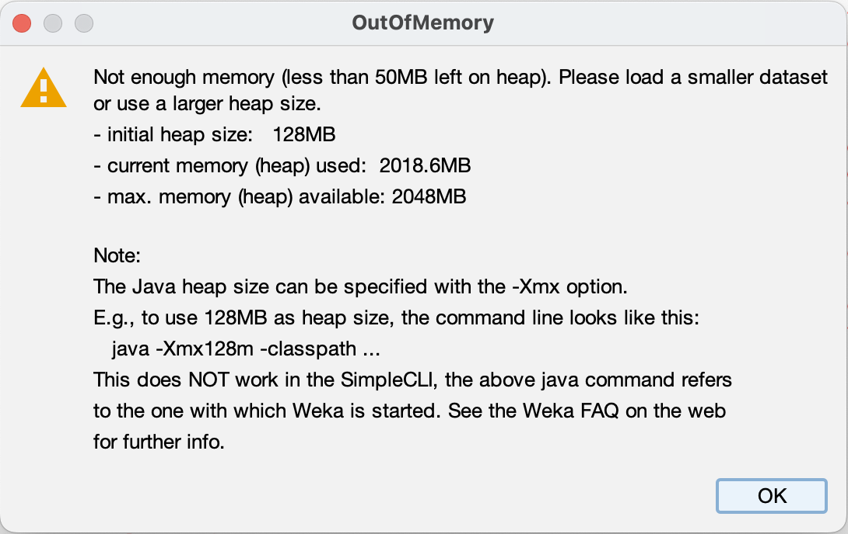

Train/Test split
We decided to use 70% of the data as a training set, and the other 30% of the data as a test set. We split this test set in two, using 15% of our dataset (half of the test set) as a validation set, and using another 15% of our dataset (the other half of the test set) as a final test set. Each set has a distribution of class data representative of the dataset as a whole.

Tools Used
We used the Weka remove function to remove attributes. We used Excel’s find and replace tools to replace special values with “?”, then converted the Excel file to an .arff file using Weka’s converter, setting the missing value field as “?”. We used Weka’s SubsetByExpression with the expression “not ismissing(ATT#)” to remove attributes with missing class labels. We used Weka’s ReplaceMissing values filter to fill in missing values with mean (for numerical data) and mode (for nominal data). To take a sample of our dataset, we first used Weka’s Randomize filter to randomize the dataset, then its RemovePercentage filter to remove 90% of the data. Finally, we used Weka’s RemovePercentage filter to split the dataset into training and testing sets and to split the testing set into testing and validation sets. We ensured that the split datasets did not overlap by using each percentage once with and once without the InvertSelection field as true.

Attribute Selection

Correlation
We used Weka’s correlation attribute evaluator with the ranker search method. The results were as follows. We used a cutoff value of 0.2; the attributes we removed were: SCHOOL_TYPE_TEXT, HPALM, HP, WHALM, WH, HPALF, WHALF, CHARTER_TEXT, AS_, ASALM, ASALF, ULOCALE, STUTERATIO, SY_STATUS_TEXT, LSTATE, STATUS, AMALM, AM, AMALF, VIRTUAL, SCHOOL_LEVEL, LZIP, NMCNTY, and LCITY. The attributes with a correlation greater than 0.2 were: MEMBER, TOTAL, TOTMENROL, TOTFENROL, FTE, HI, HIALM, HIALF, BLALM, BL, BLALF, TR, TRALF, and TRALM. Weka’s correlation attribute uses the Pearson correlation coefficient, calculated using equation (1), which is a measure of how strongly two variables correlate with each other linearly.
(1) $\frac{Σ(x{}_{i}-\underline{x})(y{}_{i}-\underline{y})}{Σ(x{}_{i}-\underline{x})^{2}Σ(y{}_{i}-\underline{y})^{2}}$
The results of CorrelationAttributeEval are as follows:
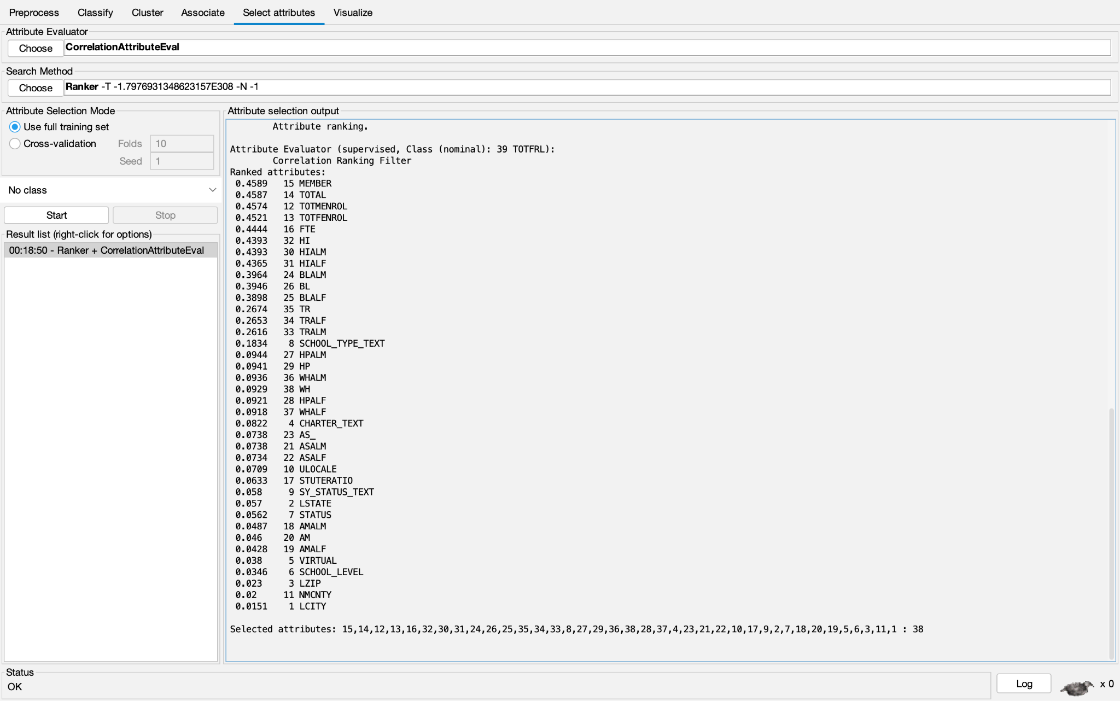

Info gain
We used Weka’s info gain attribute evaluator with the ranker search method. We used a cutoff value of 0.2; the attributes we removed were: LSTATE, LZIP, ULOCALE, TR, STUTERATIO, TRALF, TRALM, AS_, HP, ASALM, ASALF, HPALM, HPALF, AM, AMALM, SCHOOL_TYPE_TEXT, WH, WHALM, WHALF, AMALF, SCHOOL_LEVEL, CHARTER_TEXT, VIRTUAL, SY_STATUS_TEXT, and STATUS. The attributes with an info gain greater than 0.2 were: LCITY, MEMBER, TOTAL, TOTMENROL, TOTFENROL, NMCNTY, HI, HIALF, HIALM, FTE, BL, BLALF, and BLALM. Infogain is a measure of how well a variable reduces the entropy of another variable, calculated by equation (2).
(2) $InfoGain(Class, Attribute) = H(Class) - H(Class | Attribute).$
The results of InfoGainAttributeEval are as follows:
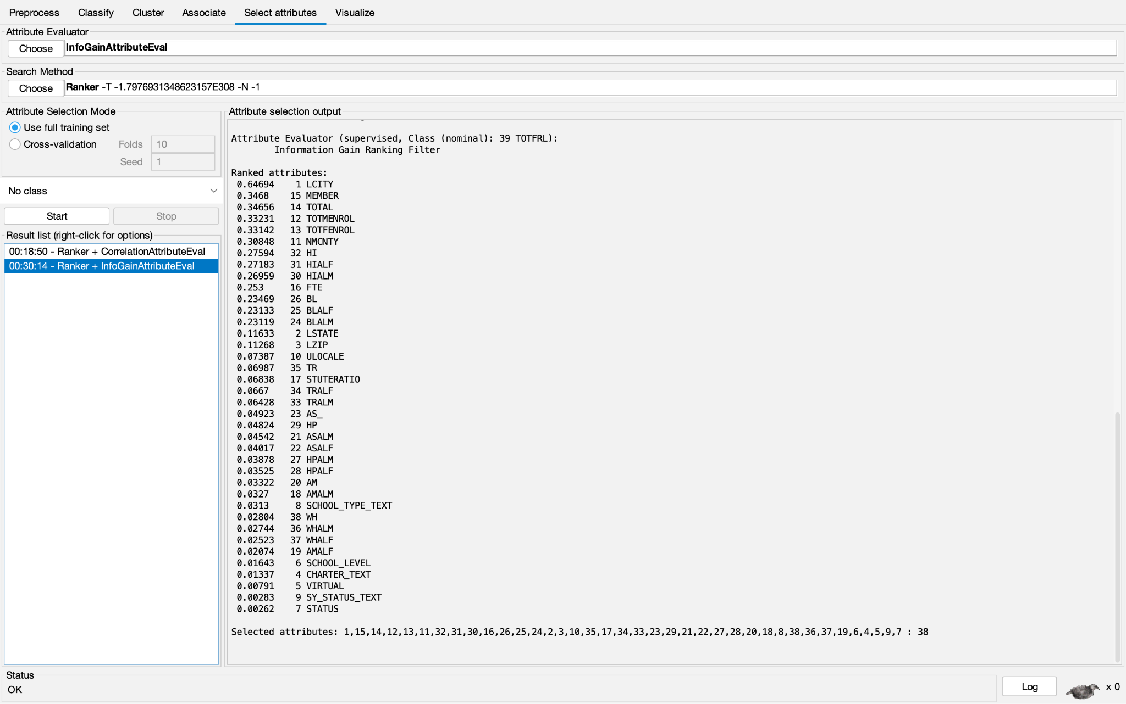

Symmetrical Uncertainty
We used Weka’s symmetrical uncertainty attribute evaluator with the ranker search method. We used a cutoff value of 0.1; the attributes removed were: NMCNTY, LZIP, STUTERATIO, SCHOOL_TYPE_TEXT, TRALF, TRALM, TR, LSTATE, HP, HPALM, AS_, ASALM, ULOCALE, ASALF, HPALF, AM, AMALM, WH, WHALM, AMALF, AMALF, WHALF, CHARTER_TEXT, SCHOOL_LEVEL, VIRTUAL, SY_STATUS_TEXT, and STATUS. The attributes with a symmetrical uncertainty value greater than 0.1 were: MEMBER, TOTAL, TOTFENROL, TOTMENROL, HIALF, HI, HIALM, FTE, BL, BLALF, BLALM, and LCITY. Symmetrical uncertainty measures the symmetrical strength of dependency between variables calculated by equation (3).
(3) $SymmU(Class, Attribute) = \frac{2 *(H(Class) - H(Class | Attribute))}{H(Class) + H(Attribute)}$
The results of SymmetricalUncertAttributeEval are as follows:
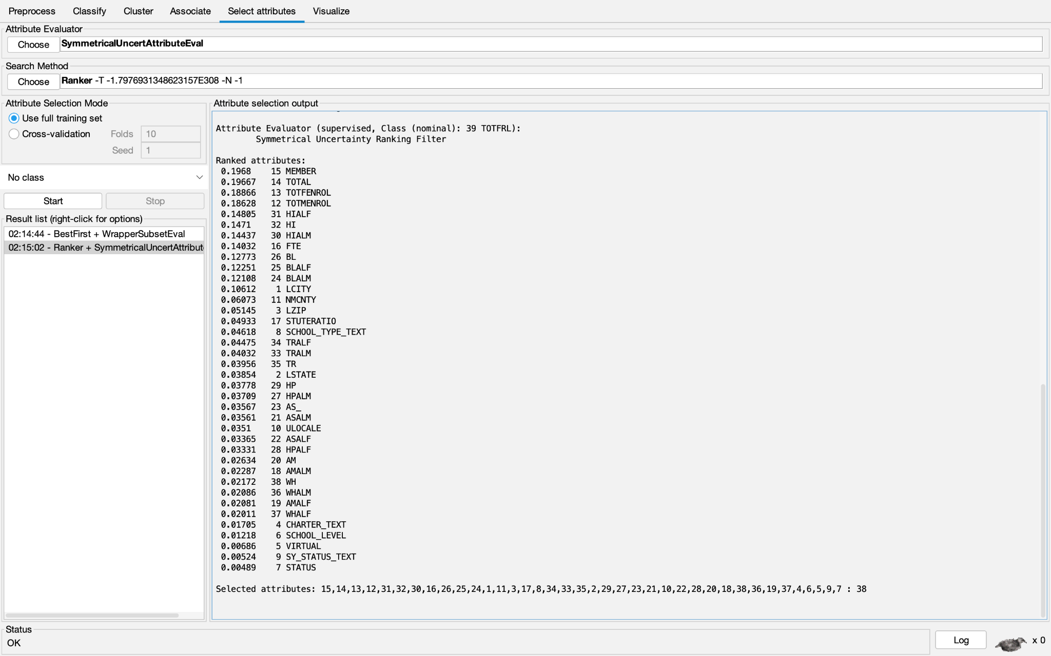

Cfs Subset
We used Weka’s cfs subset attribute evaluator with the best first search method. We chose to keep all attributes suggested by the evaluator. The attributes kept were: SCHOOL_TYPE_TEXT, TOTMENROL, TOTFENROL, TOTAL, MEMBER, FTE, STUTERATIO, BLALM, BLALF, BL, HIALM, HIALF, and HI. All other attributes were removed. CfsSubsetAttributeEval evaluates attributes by how correlated they are with the class, while also attempting to avoid selecting attributes highly correlated with each other. The results of CfsSubsetAttributeEval are as follows:
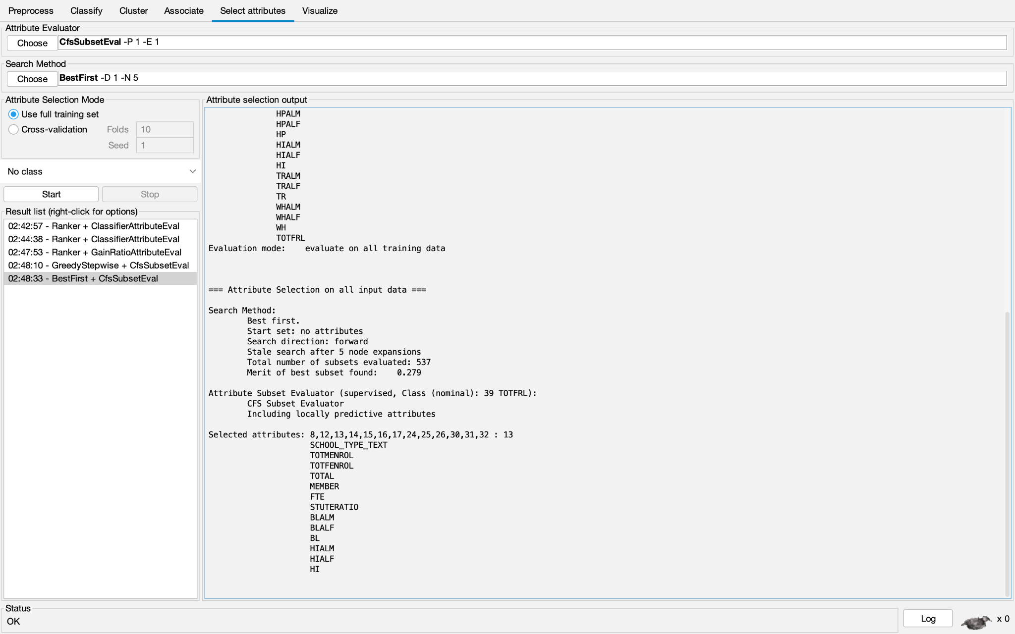

Intuition
Our final method of attribute selection was simply using our intuition. We considered how heavily we thought attributes might be related to the class, and picked the following attributes: LSTATE, LZIP, SCHOOL_LEVEL, ULOCALE, NMCITY, TOTAL, STUTERATIO, AM, AS_, BL, HP, HI, TR, and WH. All other attributes were removed.

Classification
We used the NaiveBayes, J48, 1R, and random tree classifiers. NaiveBayes uses probability to predict the class label assuming all attributes have an independent effect on the class. NaiveBayes simply calculates the probability of each class label and classifies the instance as whichever label had the highest probability. The J48 classification algorithm is a decision tree built using information entropy. The 1R classifier creates a rule to predict the output using a single single attribute. It uses only the values of this attribute to predict the class label. The random tree classifier creates multiple decision trees with random variables, and classifies each instance as the most frequently occuring tree output.

Results

CorrelationAttributeEval

NaiveBayes
Training accuracy was ~81%, validation accuracy was ~79%, testing results are as follows:
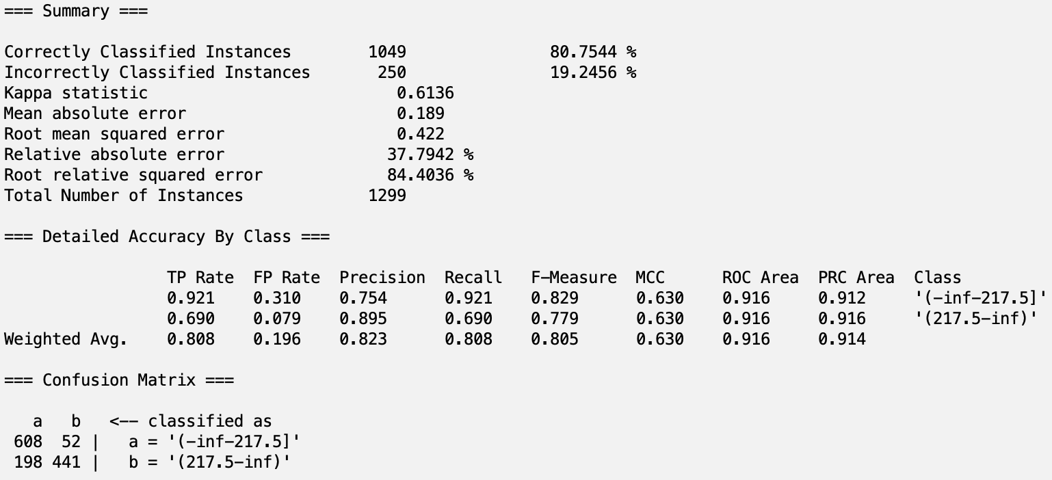

J48
Training accuracy was ~88%, validation accuracy was ~84%, testing results are as follows:
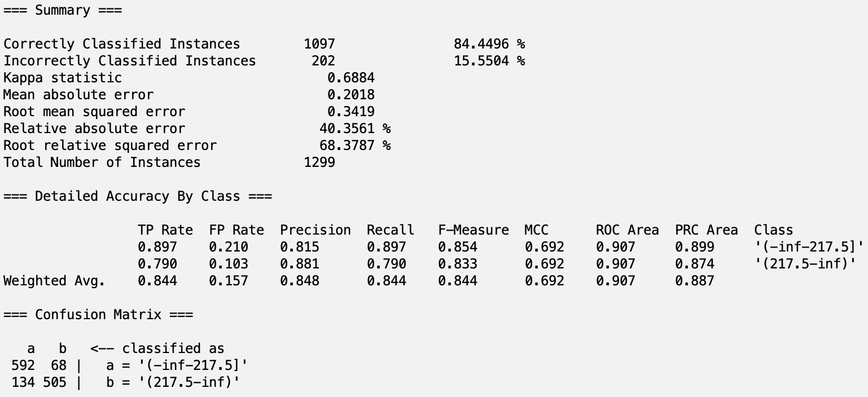

1R
Training accuracy was ~79%, validation accuracy was ~74%, testing results are as follows:
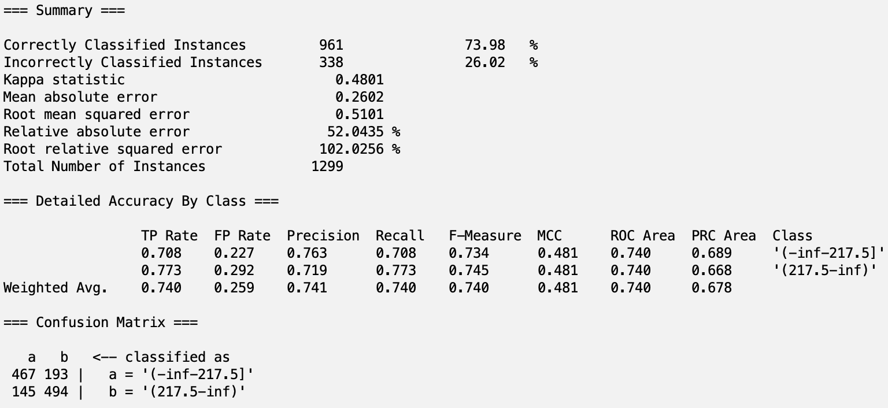

Random Tree
Training accuracy was ~100%, validation accuracy was ~80%, testing results are as follows:
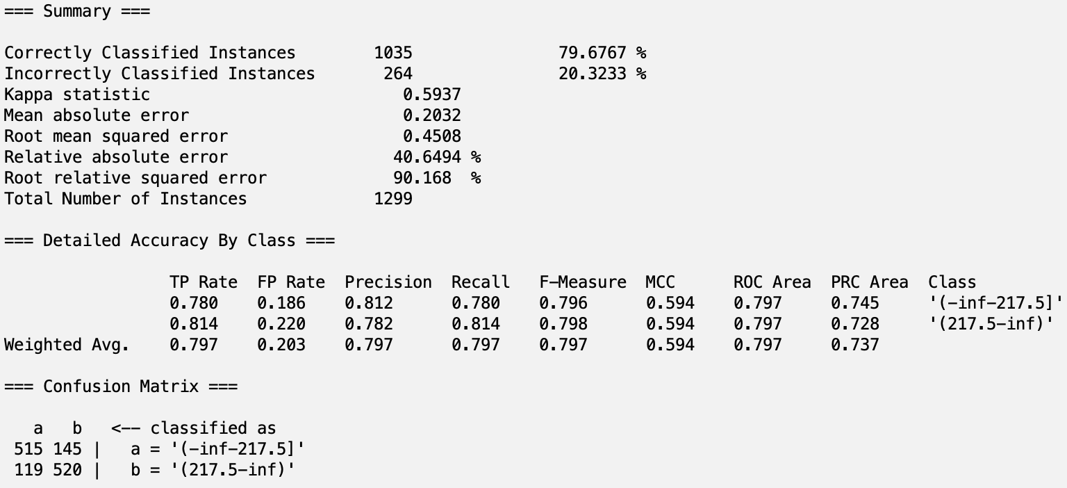

InfoGainAttributeEval

NaiveBayes
Training accuracy was ~82%, validation accuracy was ~80%, testing results are as follows:
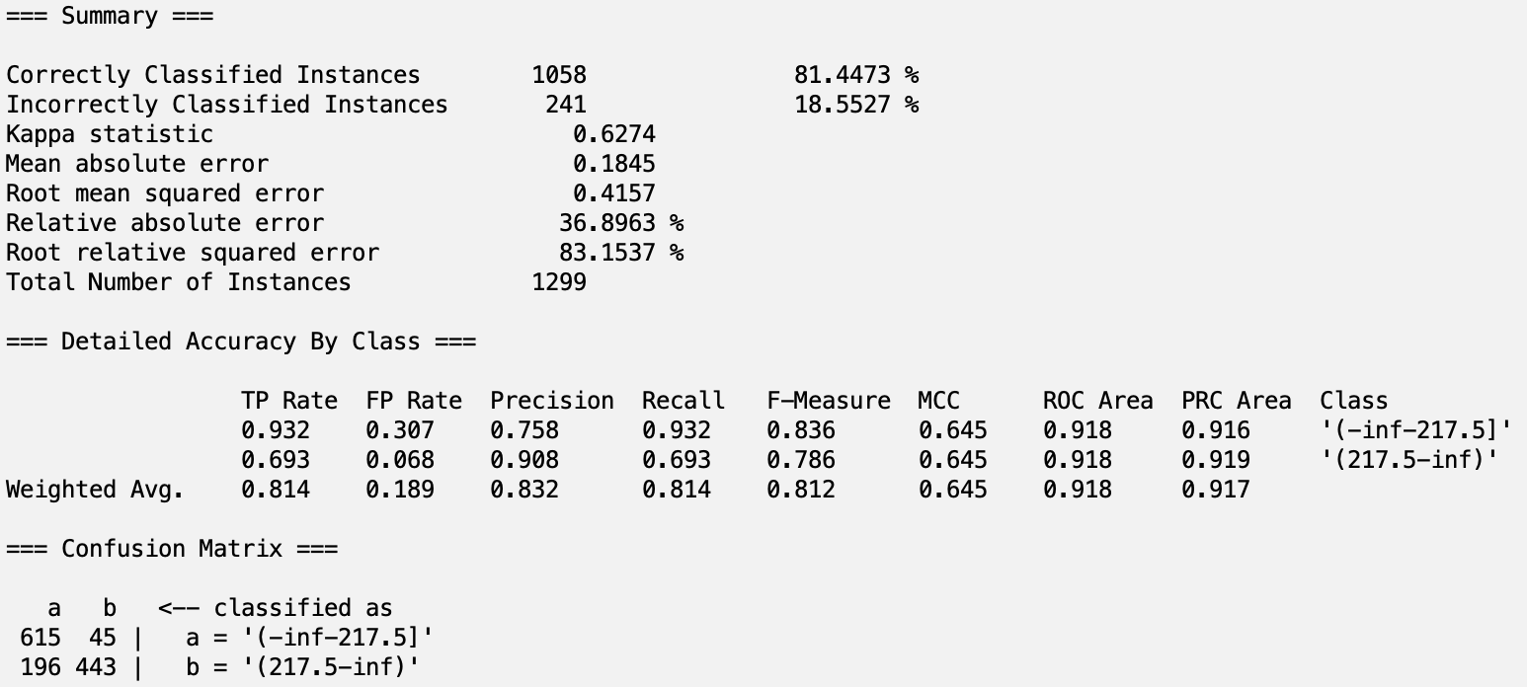

J48
Training accuracy was ~82%, validation accuracy was ~82%, testing results are as follows:
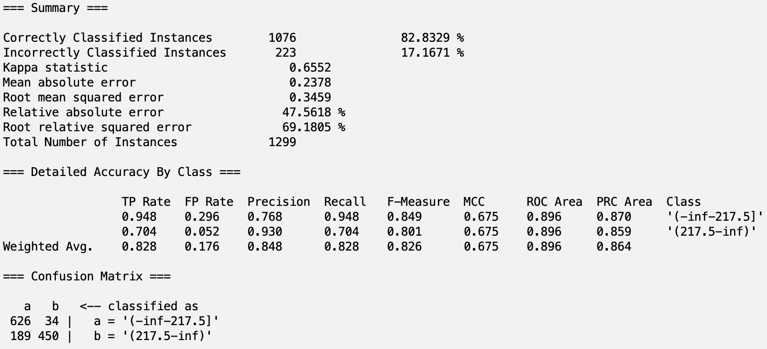

1R
Training accuracy was ~86%, validation accuracy was ~63%, testing results are as follows:
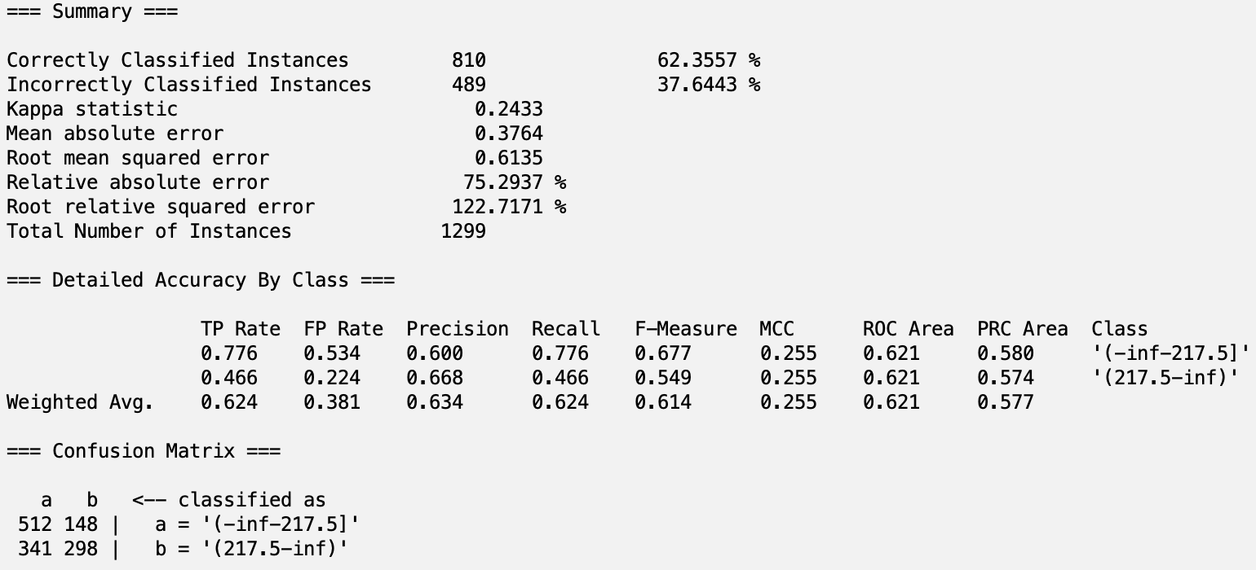

Random Tree
Training accuracy was ~100%, validation accuracy was ~76%, testing results are as follows:
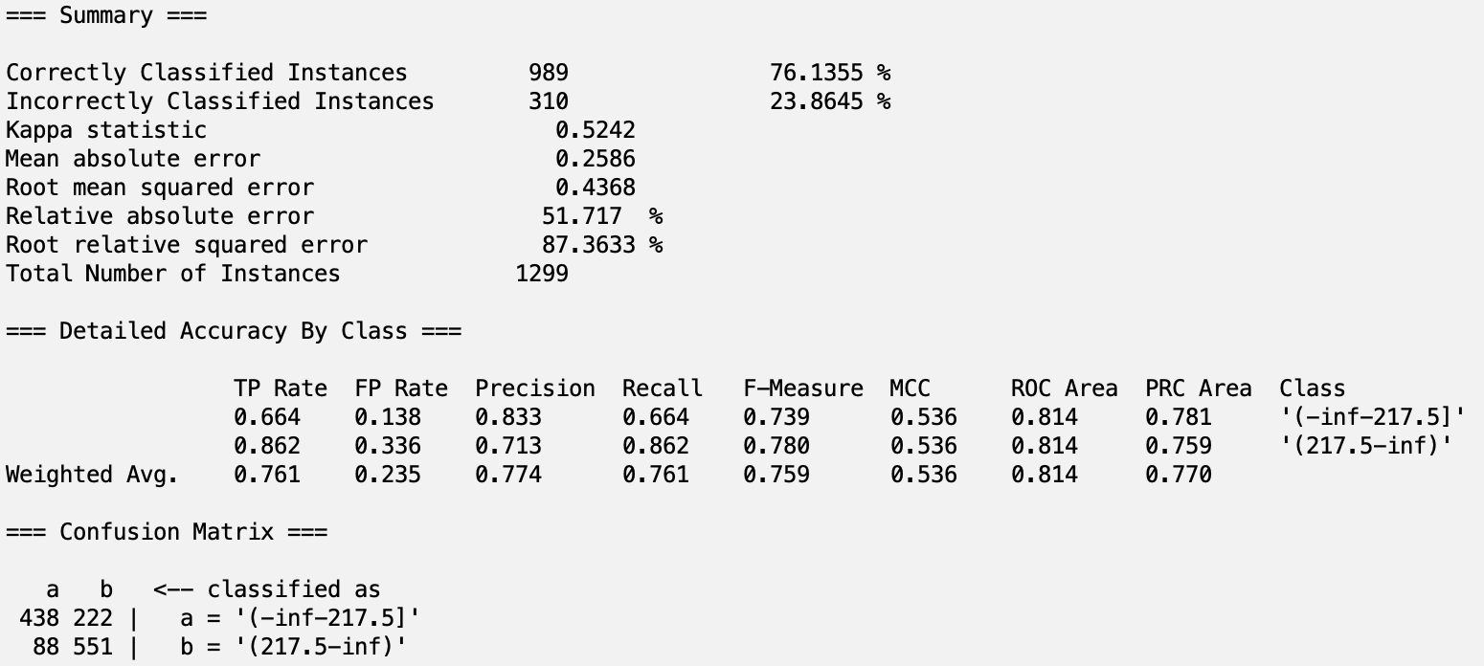

SymmetricalUncertAttributeEval

NaiveBayes
Training accuracy was ~81%, validation accuracy was ~80%, testing results are as follows:
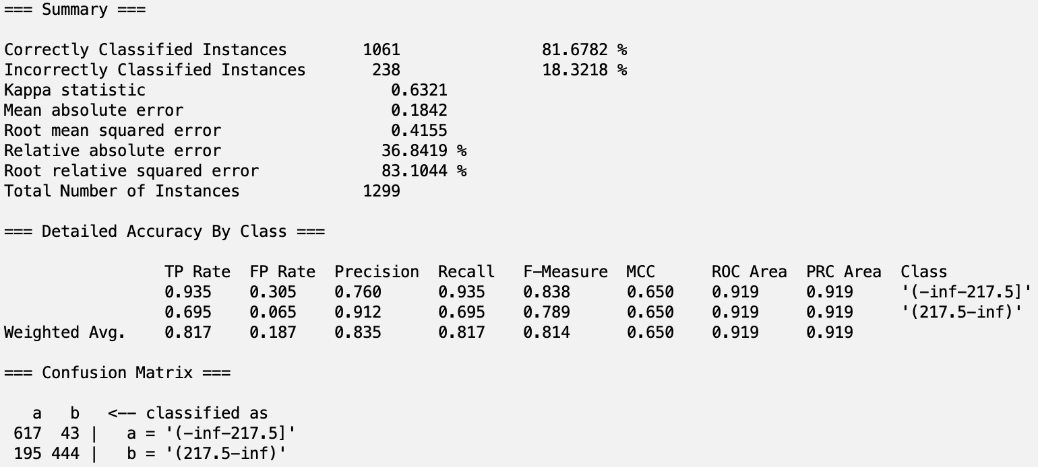

J48
Training accuracy was ~83%, validation accuracy was ~82%, testing results are as follows:
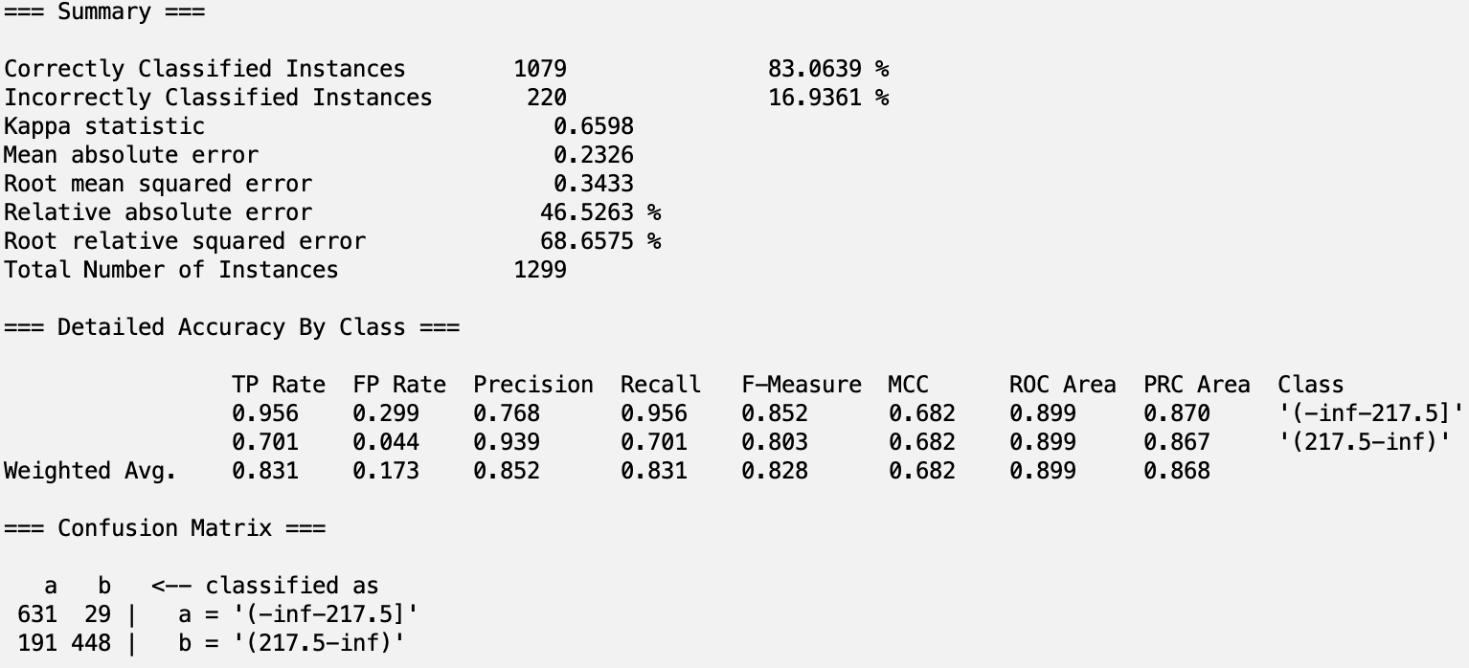

1R
Training accuracy was ~86%, validation accuracy was ~64%, testing results are as follows:
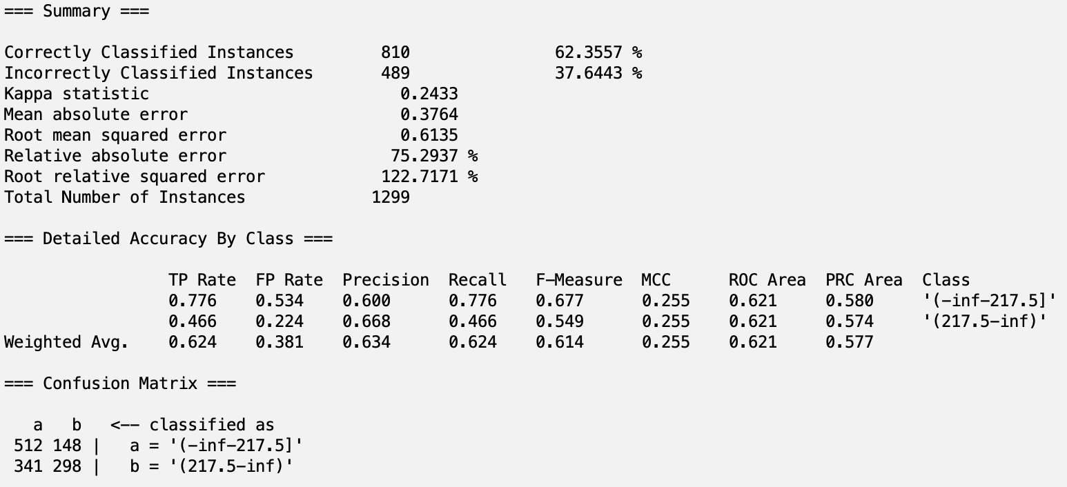

Random Tree
Training accuracy was ~100%, validation accuracy was ~75%, testing results are as follows:

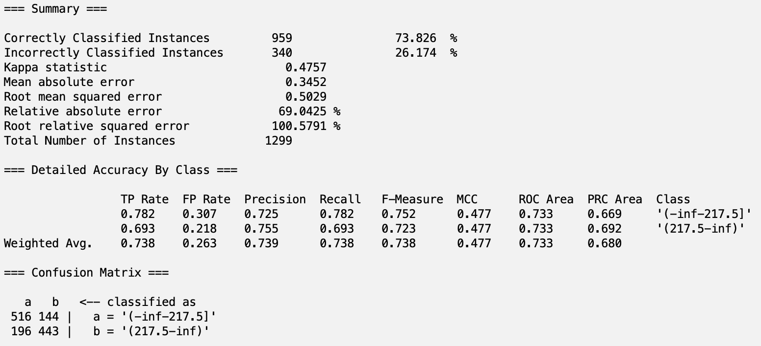

CfsSubsetAttributeEval

NaiveBayes
Training accuracy was ~81%, validation accuracy was ~80%, testing results are as follows:
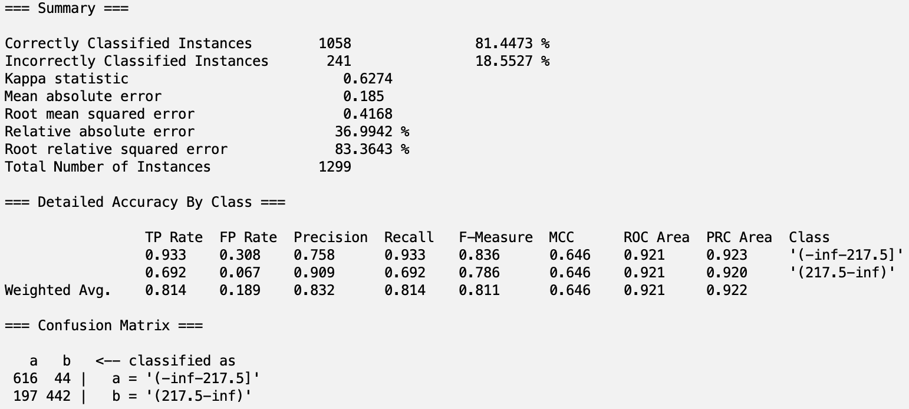

J48
Training accuracy was 88%, validation accuracy was ~84%, testing results are as follows:
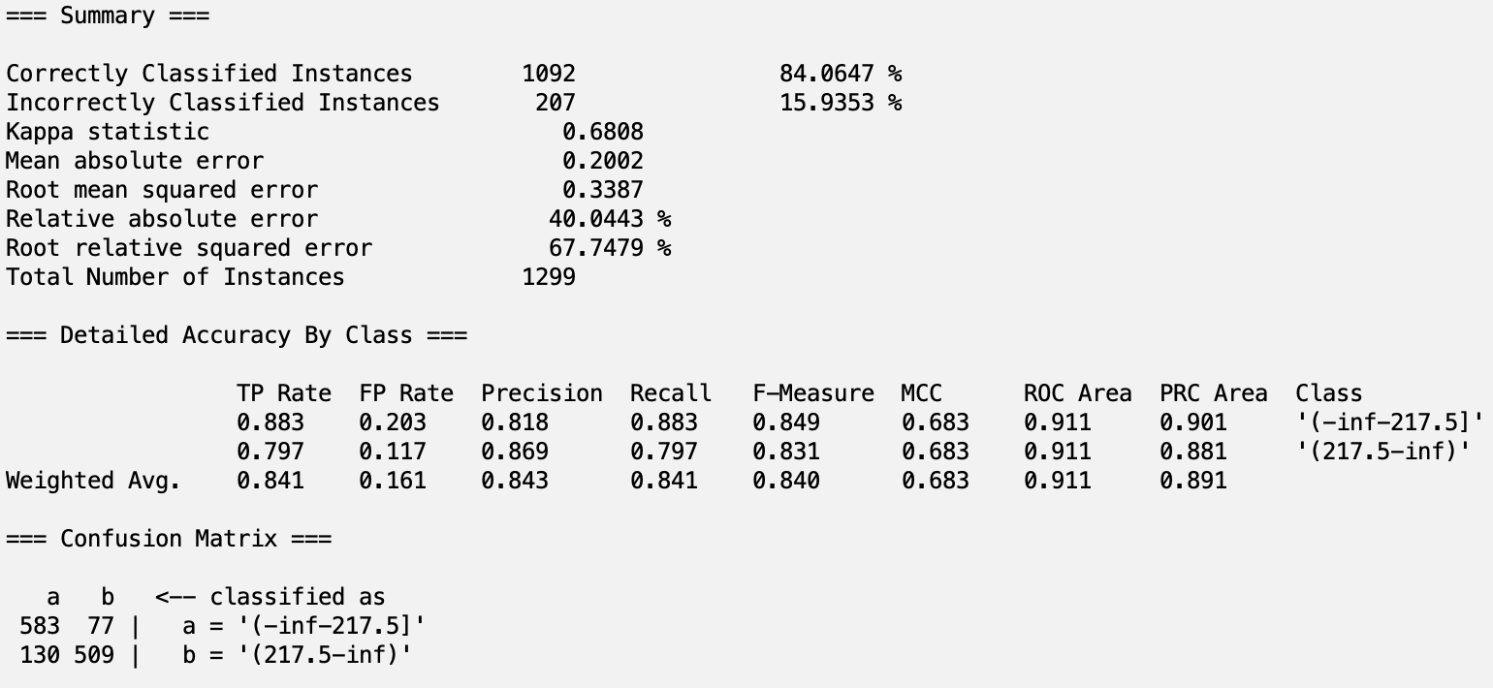

1R
Training accuracy was ~79%, validation accuracy was ~74%, testing results are as follows:
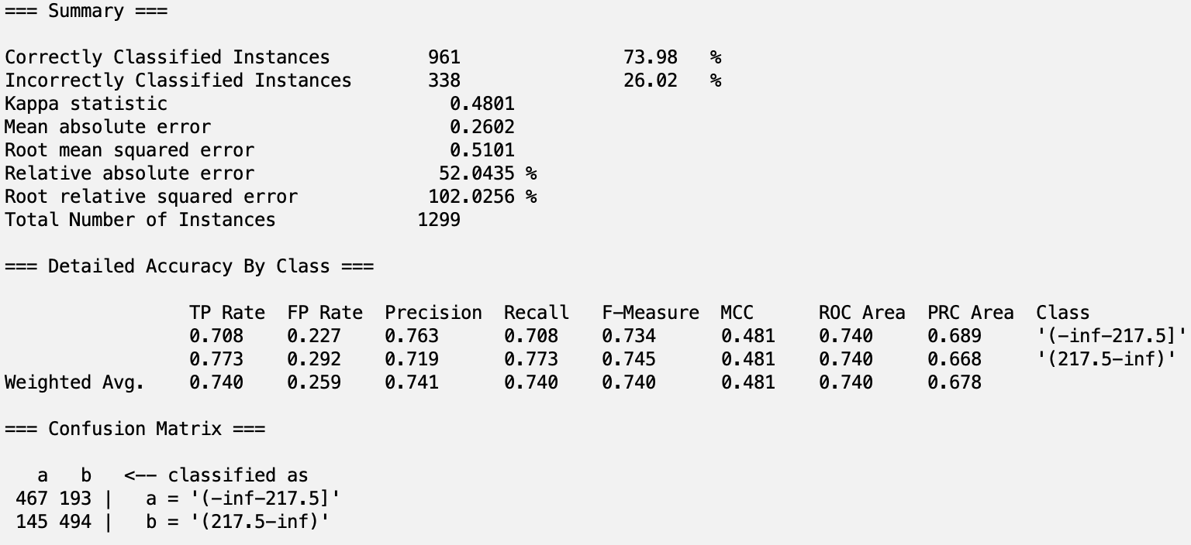

Random Tree
Training accuracy was ~100%, validation accuracy was ~80%, testing results are as follows:
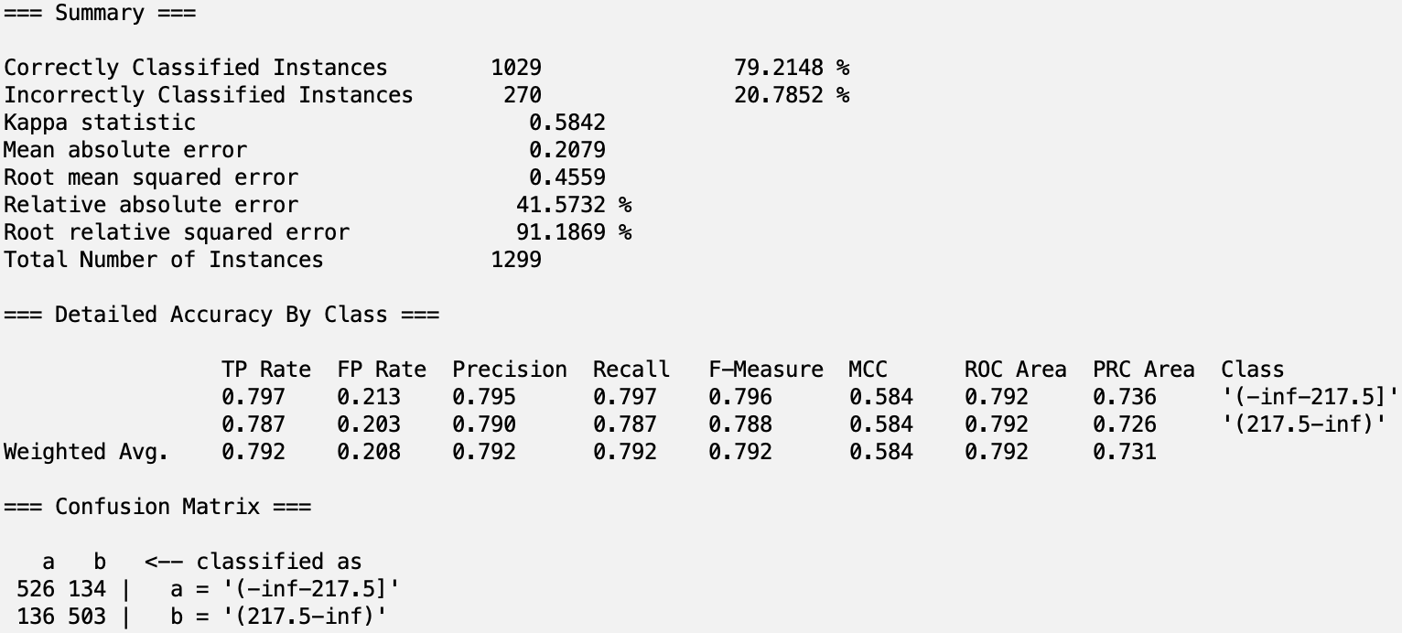

Intuition

NaiveBayes
Training accuracy was ~80%, validation accuracy was ~80%, testing results are as follows:
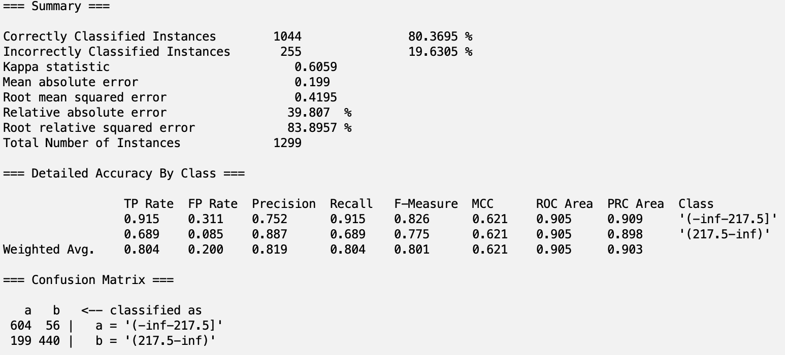

J48
Training accuracy was ~84%, validation accuracy was ~84%, testing results are as follows:
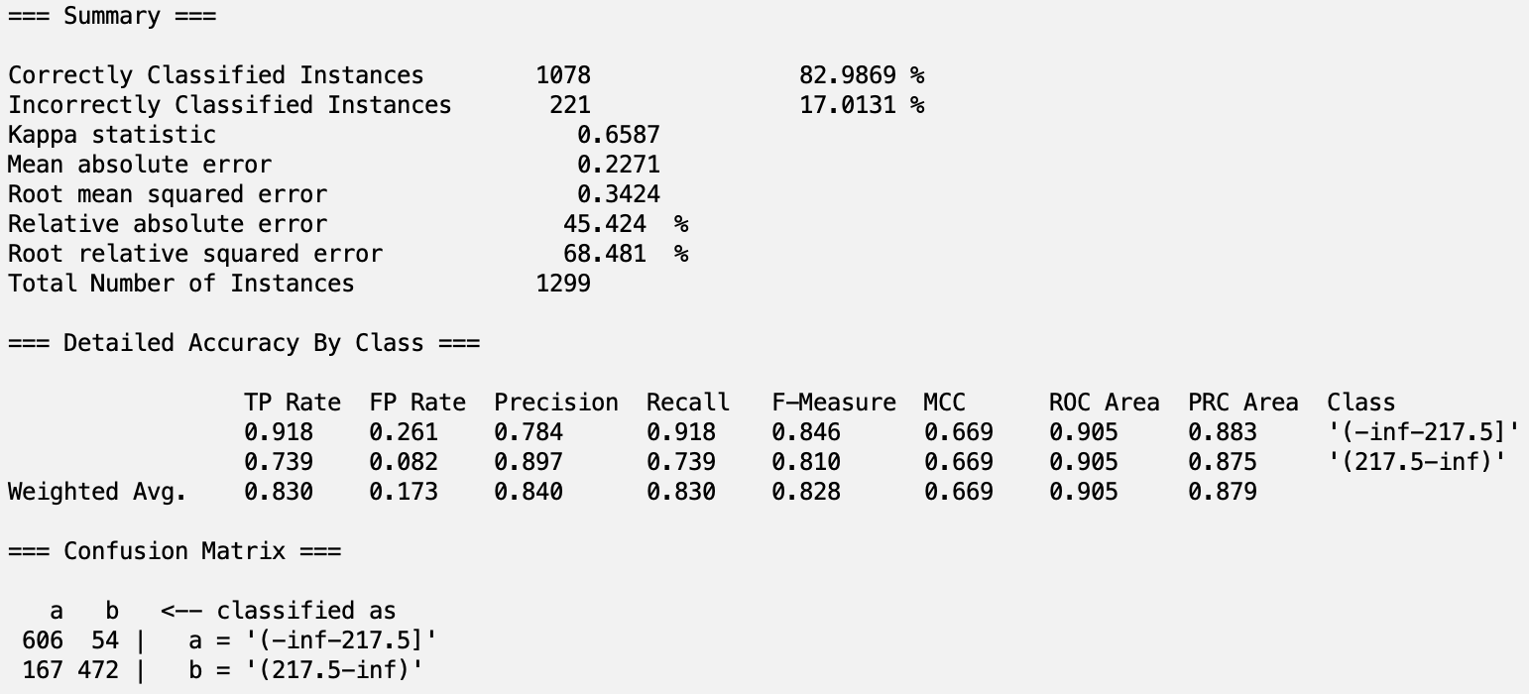

1R
Training accuracy was ~79%, validation accuracy was ~74%, testing results are as follows:

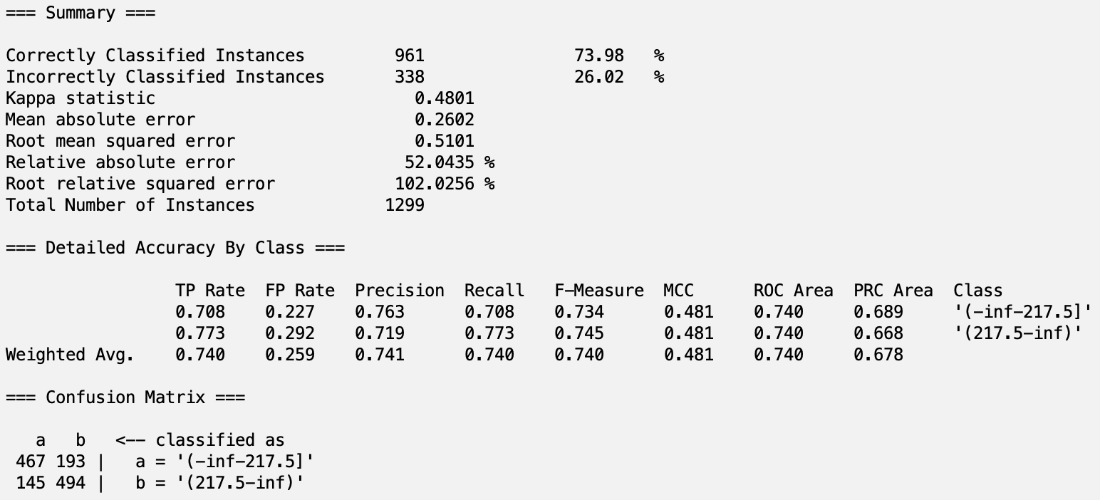

Random Tree
Training accuracy was ~100%, validation accuracy was ~75%, testing resultsare as follows:
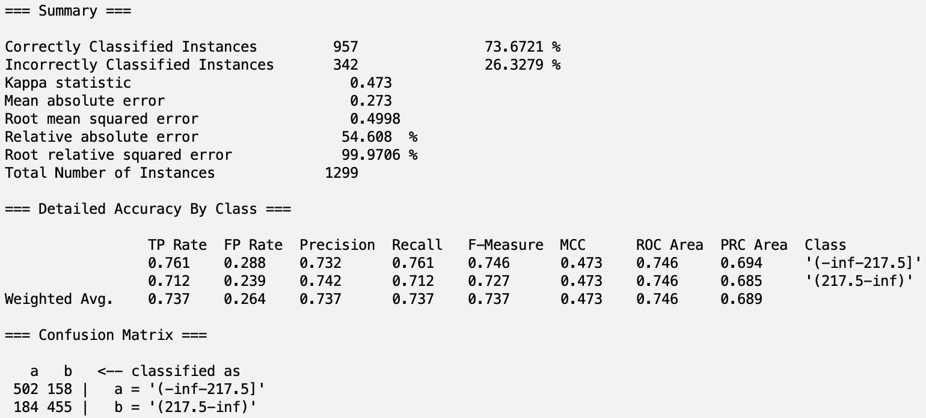

Analysis
From our results, we can see that CorrelationAttributeEval and CfsSubsetAttributeEval with J48 performed best with a testing accuracy of 84%. We can also that CfsSubsetAttributeEval with
NaiveBayes had the highest ROC area meaning that this particular classification model has a strong ability to distinguish between positive and negative classes. In the differences between the accuracy on the training and validation sets we can see that Random Trees in general tended to overfit the data resulting from a near %100 accuracy on the training dataset to a substantial difference on the validation dataset accuracy. Best Model in terms of F-score is J48 in both CorrelationAttributeEval and CfsSubsetAttributeEval with value of 0.84 So , Overall, the best model for our dataset would be either CorrelationAttributeEval with J48 or CfsSubsetAttributeEval with J48 because both perform very similarly and are the best classifiers when dealing with overfitting, underfitting, and F1 score.

Team Members and Tasks Performed
Finding the Data & Building Proposal: Lucas
Preprocessing Initial Attempt: Parasmai
Preprocessing & Project Update: Lucas
Non-Weka Attribute Selection Algorithm: Lucas
Attribute Selection Algorithms and Classifiers: Lucas
Results Output: Lucas
Results Analysis: Parasmai
Building Final Report: Lucas
Final Presentation: Parasmai

Appendix

Attributes
# | Name | Description | Missing Values
1 | OBJECTID | instance number | 0
2 | NCESSCH | Unique School ID | 0
3 | SURVYEAR | Year corresponding to survey record | 0
4 | STABR | Postal state abbreviation code | 0
5 | LEAID | NCES Agency ID | 0
6 | ST_LEAID | State Local Education Number | 0
7 | LEA_NAME | Education Agency Name | 0
8 | SCH_NAME | School Name | 0
9 | LSTREET1 | Location address, street 1 | 0
10 | LSTREET2 | Location address, street 2 | 100817
11 | LCITY | Location city | 0
12 | LSTATE | Location state | 0
13 | LZIP | Location 5 digit ZIP code | 0
14 | LZIP4 | Location Secondary ZIP code | 42811
15 | PHONE | Telephone number | 0
16 | CHARTER_TEXT | Whether a Charter School | 0
17 | VIRTUAL | Virtual School Status | 0
18 | GSLO | Grades Offered - Lowest | 0
19 | GSHI | Grades Offered - Highest | 0
20 | SCHOOL_LEVEL | School level | 0
21 | STATUS | Start of year status (code) | 0
22 | SCHOOL_TYPE_TEXT | School type (description) | 0
23 | SY_STATUS_TEXT | Start of year status (description) | 0
24 | ULOCALE | Locale Code | 0
25 | NMCNTY | County Name | 0
26 | FRELCH | Free Lunch Program | 0
27 | REDLCH | Reduced-Lunch Program | 0
28 | DIRECTCERT | Direct Certification | 0
29 | PK | Prekindergarten students | 68998
30 | KG | Kindergarten students | 47329
31 | G01 | Grade 1 students | 46978
32 | G02 | Grade 2 students | 46921
33 | G03 | Grade 3 students | 46931
34 | G04 | Grade 4 students | 47132
35 | G05 | Grade 5 students | 48376
36 | G06 | Grade 6 students | 63367
37 | G07 | Grade 7 students | 68166
38 | G08 | Grade 8 students | 67898
39 | G09 | Grade 9 students | 73289
40 | G10 | Grade 10 students | 73501
41 | G11 | Grade 11 students | 73502
42 | G12 | Grade 12 students | 73574
43 | G13 | Grade 13 students | 101257
44 | UG | Ungraded students | 93501
45 | AE | Adult Education Students | 101207
46 | TOTMENROL | Total Male Enrollment | 2480
47 | TOTFENROL | Total Female Enrollment | 2480
48 | TOTAL | Total students | 1671
49 | MEMBER | Total elementary/secondary students (excludes adult enrollment) | 1671
50 | FTE | Total teachers | 3853
51 | STUTERATIO | Student-teacher ratio | 1814
52 | AMALM | American Indian/Alaska Native Male students | 2581
53 | AMALF | American Indian/Alaska Native Female students | 2579
54 | AM | American Indian/Alaska Native students | 2533
55 | ASALM | Asian students Male | 2492
56 | ASALF | Asian students Female | 2490
57 | AS_ | Asian students | 2484
58 | BLALM | Black or African American students Male | 2494
59 | BLALF | Black or African American students Female | 2497
60 | BL | Black or African American students | 2487
61 | HPALM | Native Hawai’ian or Other Pacific Islander students Male | 2608
62 | HPALF | Native Hawai’ian or Other Pacific Islander students Female | 2607
63 | HP | Native Hawai’ian or Other Pacific Islander students | 2561
64 | HIALM | Hispanic students Male | 2481
65 | HIALF | Hispanic students Female | 2480
66 | HI | Hispanic students | 2480
67 | TRALM | Two or more races students Male | 2487
68 | TRALF | Two or more races students Female | 2485
69 | TR | Two or more races students | 2484
70 | WHALM | White students Male | 2481
71 | WHALF | White students Female | 2481
72 | WH | White students | 2480
73 | LATCOD | Latitude | 0
74 | LONCOD | Longitude | 0
75 | TOTFRL | Total of free lunch and reduced-price lunch eligible | 0
 | Total |  | 1,078,417

Sources
Dataset: https://catalog.data.gov/dataset/public-school-characteristics-current-340b1

